EXPT NO: 7 | GENERATE SYNTHETIC IMAGES USING A GENERATIVE ADVERSARIAL NETWORK (GAN)
DATE:

PRE-LAB QUESTIONS (PROVIDE BRIEF ANSWERS TO THE FOLLOWING QUESTIONS)

- What is a Generative Adversarial Network (GAN)?
A Generative Adversarial Network (GAN) is a type of deep learning model used to generate new data, such as images, that looks similar to real data. It consists of two neural networks called the Generator and Discriminator, which compete with each other during training.

- What are the roles of the Generator and Discriminator in a GAN?
• Generator: Creates fake or synthetic data from random noise and tries to make it look like real data.
• Discriminator: Examines the data and determines whether it is real or generated (fake).
• The Generator improves by trying to fool the Discriminator, while the Discriminator improves by detecting fake data.

- Why are GANs used for synthetic image generation?
GANs are used because they can generate realistic and high-quality images that resemble the training data. They can create new images without directly copying existing images and are useful in areas such as image enhancement, art generation, data augmentation, and face generation.

- What is the difference between real images and synthetic images?
Real images are captured or created from actual real-world objects, people, or scenes using cameras or other sources.
Synthetic images are artificially generated by computer algorithms or AI models such as GANs. Synthetic images may look realistic but are not directly captured from the real world.
- Explain the concept of adversarial training in GANs.
Adversarial training is the process in which the Generator and Discriminator compete. The Generator creates fake images, while the Discriminator tries to identify them as fake. As training continues, the Generator becomes better at producing realistic images, and the Discriminator becomes better at detecting fake ones. This competition helps the GAN produce highly realistic synthetic data.

AIM
To implement a Generative Adversarial Network (GAN) for generating synthetic images by training a Generator and Discriminator on an image dataset and evaluating the quality of the generated images.

SOFTWARE REQUIREMENTS
- Python
- TensorFlow / Keras
- Google Colab
- GitHub
- NumPy
- Matplotlib
- Pandas

OBJECTIVES
Students will be able to:
- Understand the architecture and working of Generative Adversarial Networks.
- Understand the roles of the Generator and Discriminator.
- Prepare and preprocess an image dataset for GAN training.
- Build a Generator network for synthetic image generation.
- Build a Discriminator network for distinguishing real and generated images.
- Train a GAN using adversarial learning.
- Generate synthetic images using the trained Generator.
- Visualize and analyze the quality of generated images.

PROCEDURE
PART A: DATASET PREPARATION AND IMAGE PREPROCESSING
Perform the following tasks:
- Load an image dataset such as the MNIST handwritten digit dataset.
- Explore the dataset and examine sample images.
- Check the number of images and image dimensions.
- Display sample images from the dataset.
- Normalize the pixel values to the range [-1, 1].
- Reshape the images into the required input format.
- Prepare the dataset for batch-wise training.
- Create a data pipeline using appropriate TensorFlow/Keras utilities.

CODE:
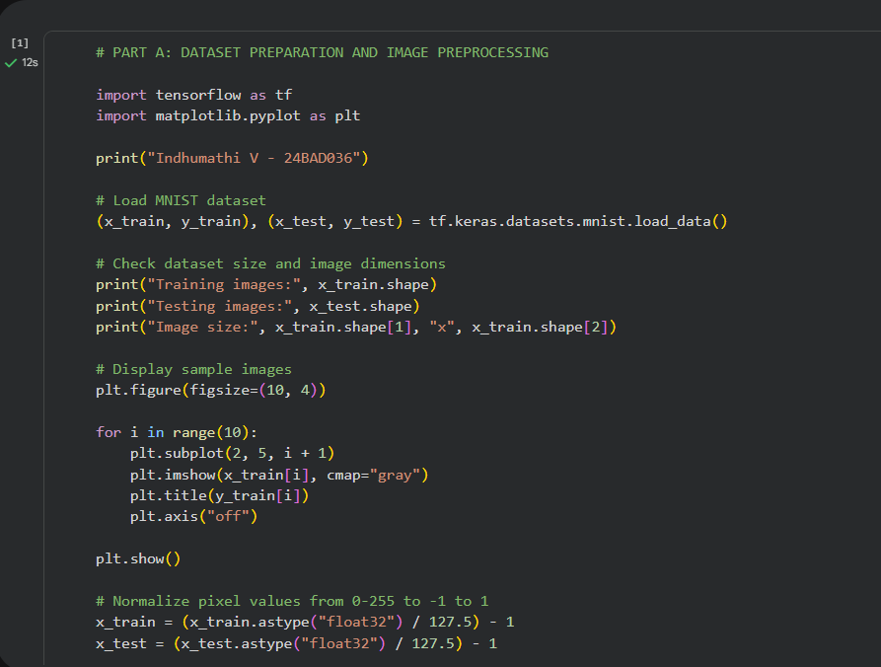
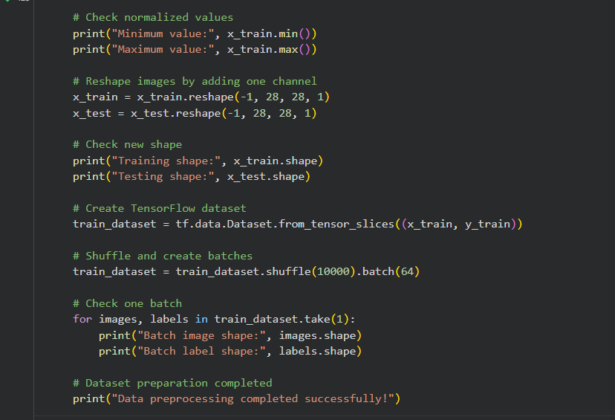

OUTPUT:
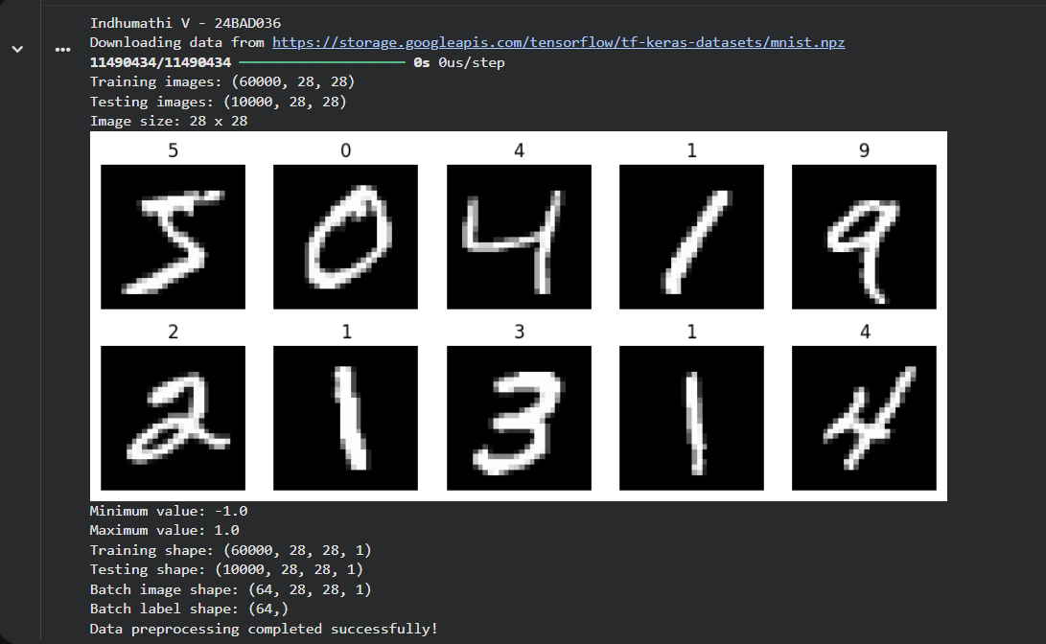

PART B: IMPLEMENTING THE GENERATOR
Perform the following tasks:
- Define a random noise vector as the input to the Generator.
- Create the Generator using appropriate neural network layers.
- Use Dense and convolutional/transposed convolutional layers to generate images.
- Apply appropriate activation functions.
- Generate an image from a random noise vector.
- Display the generated image before GAN training.
- Display the Generator model architecture and summary.

CODE:
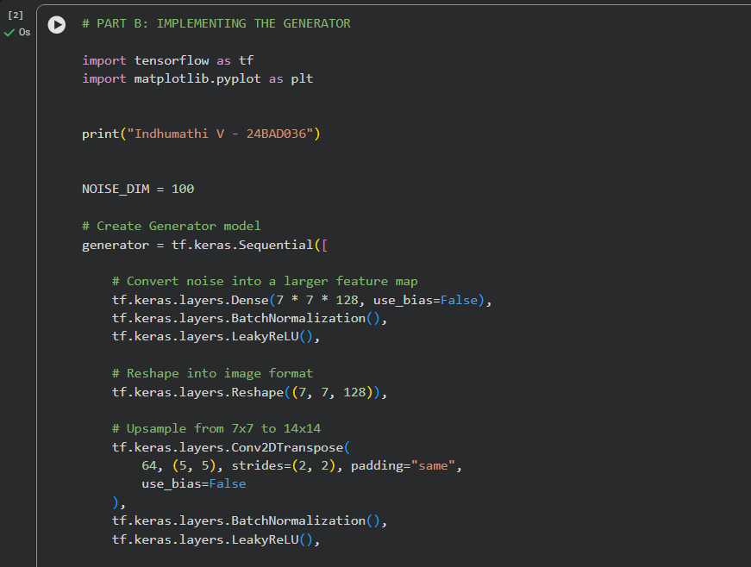
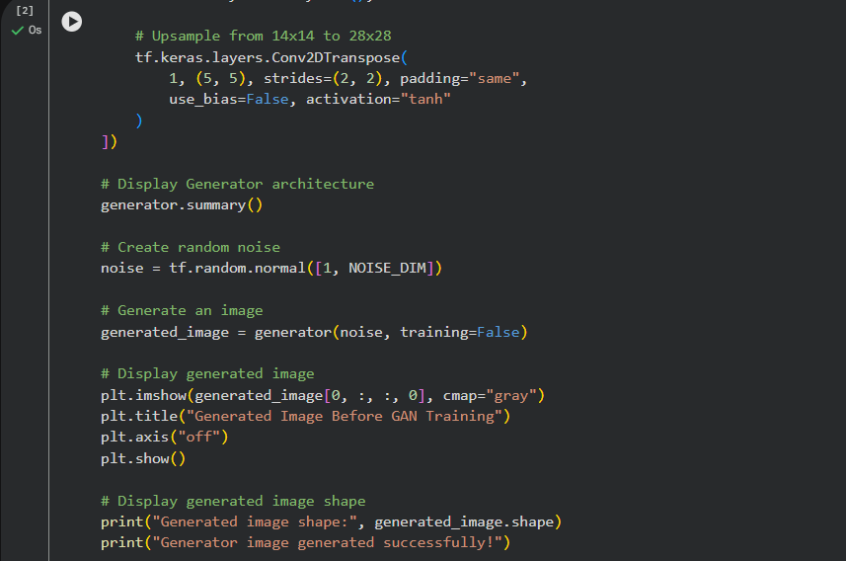

OUTPUT:
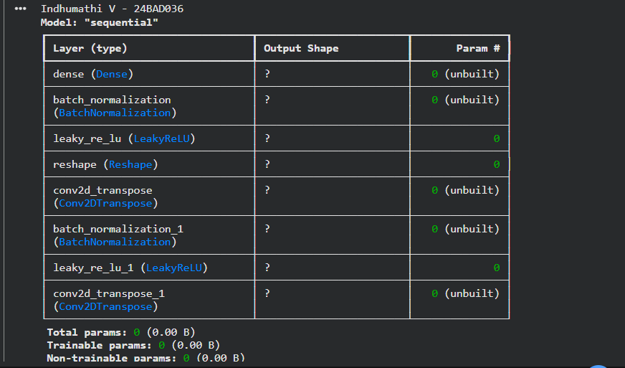
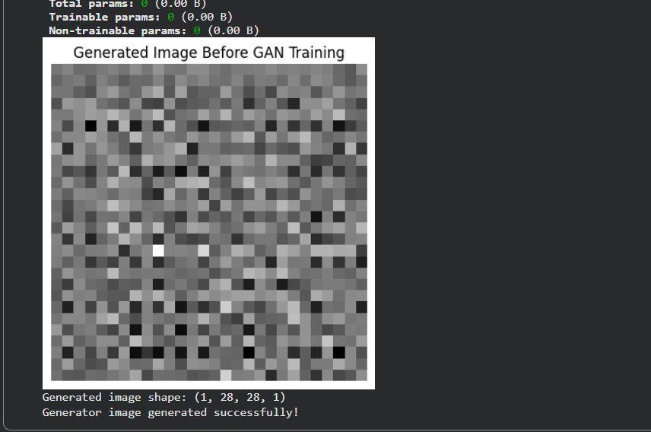
PART C: IMPLEMENTING THE DISCRIMINATOR AND GAN MODEL
Perform the following tasks:
- Create a Discriminator network to classify images as real or generated.
- Add convolutional layers to extract image features.
- Add appropriate activation functions.
- Add a final output layer for binary classification.
- Compile the Discriminator using:
  - Appropriate optimizer
  - Binary cross-entropy loss
- Combine the Generator and Discriminator to form the GAN.
- Display the Generator and Discriminator model summaries.

CODE:
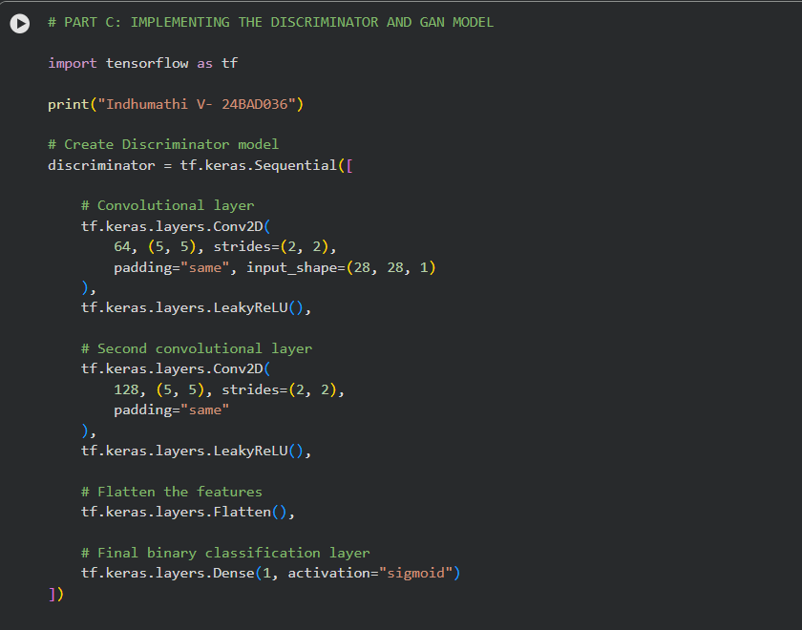
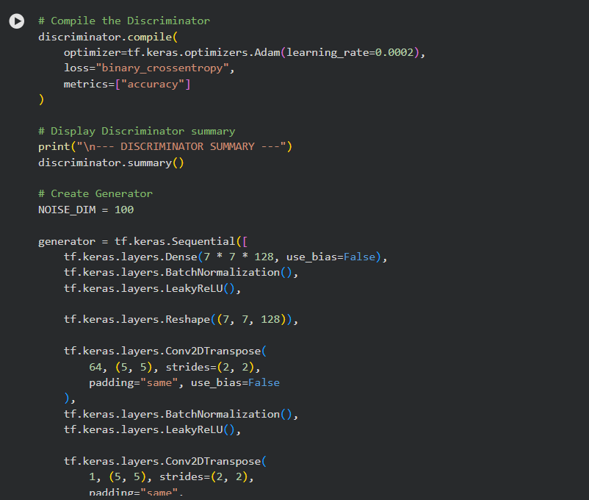
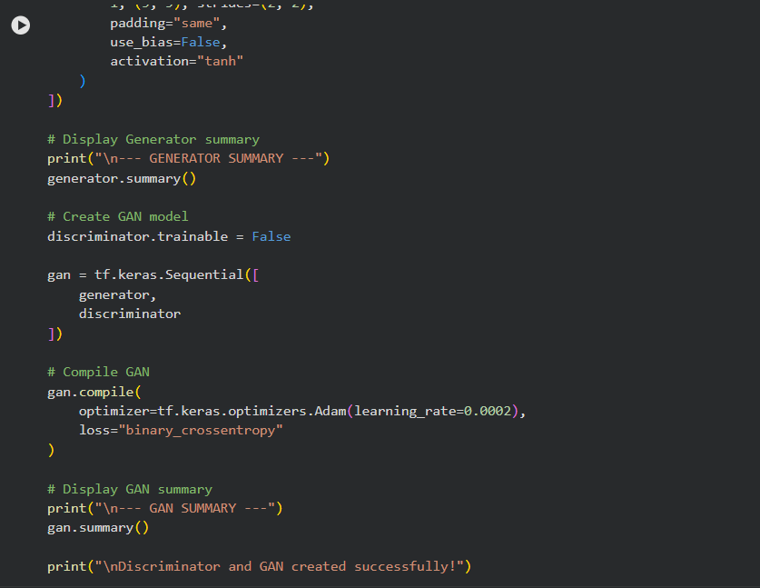
OUTPUT:
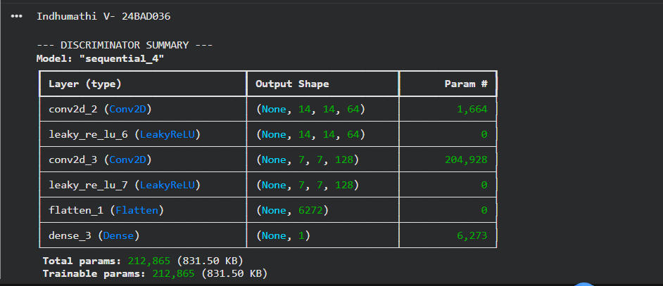
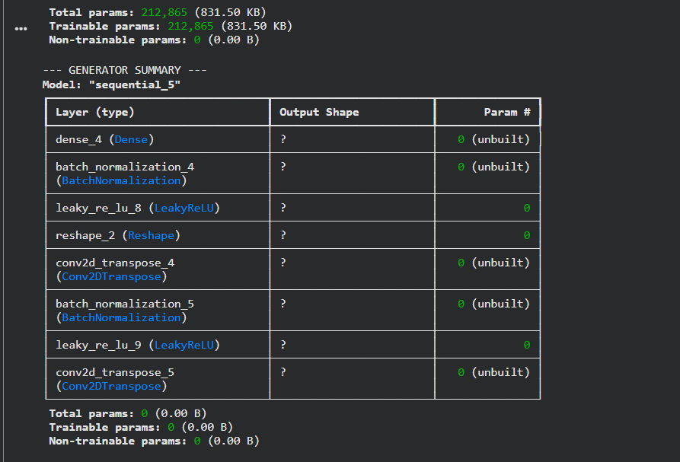
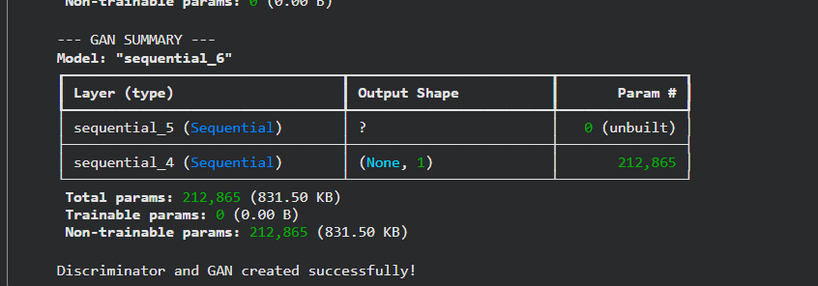

PART D: GAN TRAINING AND SYNTHETIC IMAGE GENERATION
Perform the following tasks:
- Initialize the Generator with random noise.
- Train the Discriminator using:
  - Real images from the dataset.
  - Synthetic images generated by the Generator.
- Train the Generator through the combined GAN model.
- Record:
  - Generator loss
  - Discriminator loss
- Repeat the training process for the specified number of epochs.
- Generate synthetic images at regular training intervals.
- Visualize generated images at different stages of training.
- Compare the generated images with real images.
- Analyze the quality and diversity of the generated images.
- Save the final generated images.

CODE:
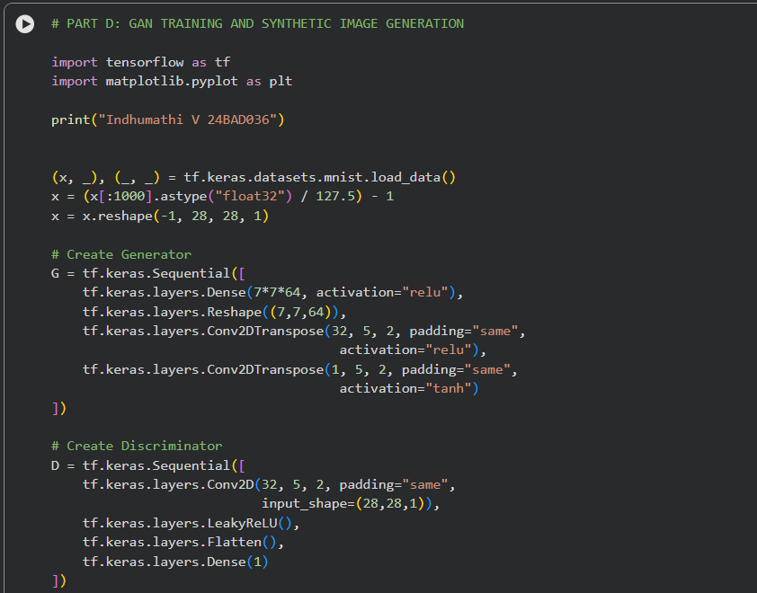
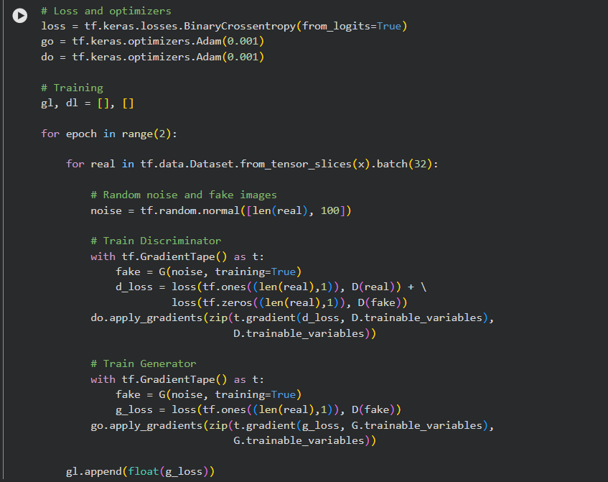
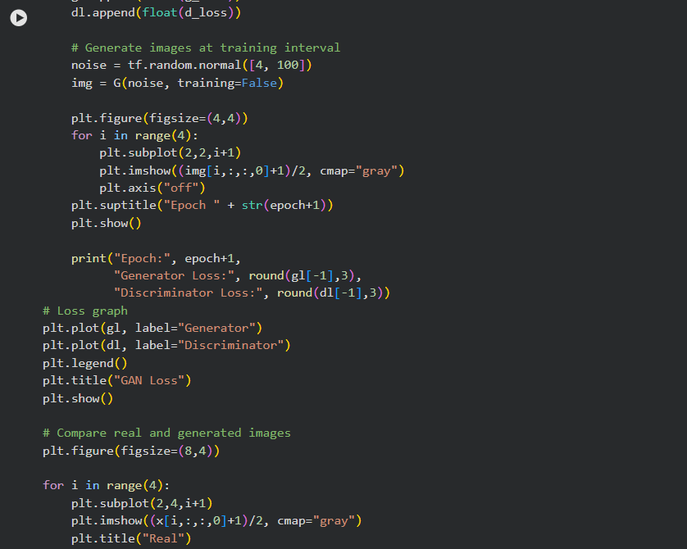
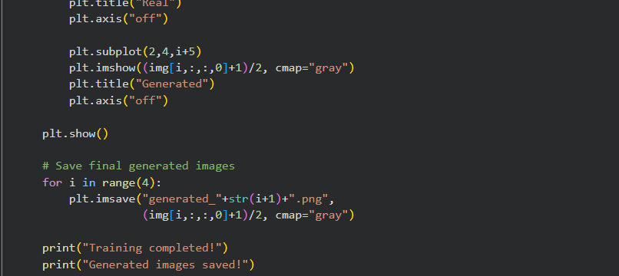

OUTPUT:
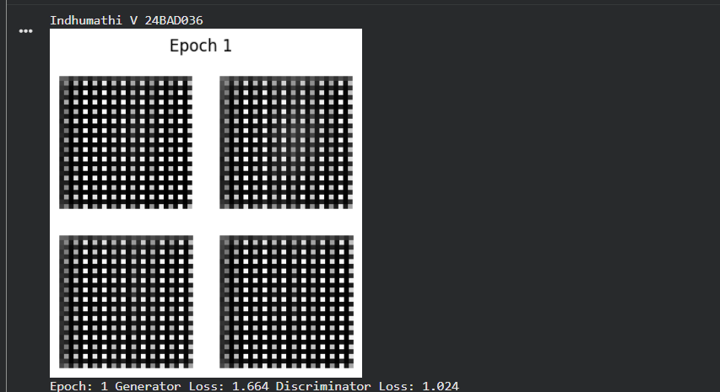
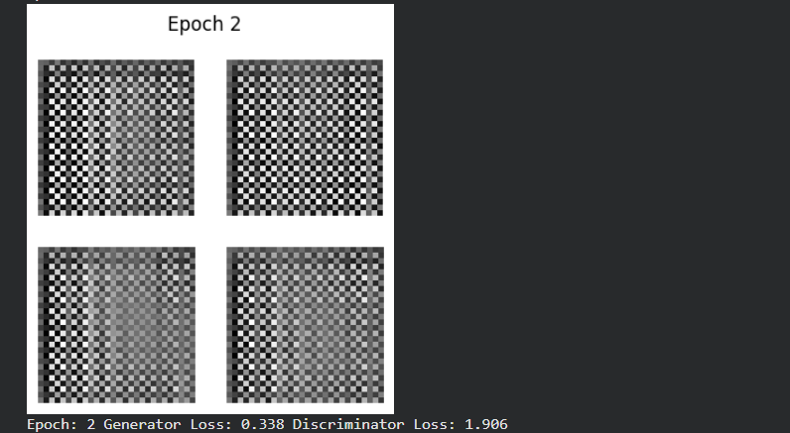
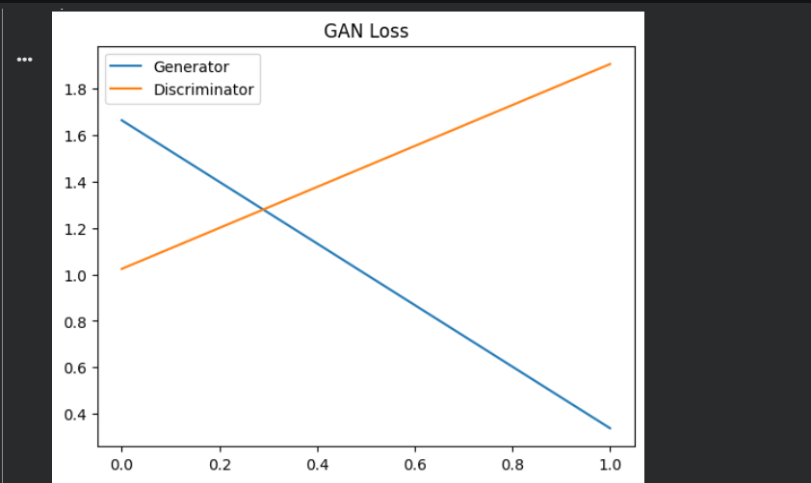
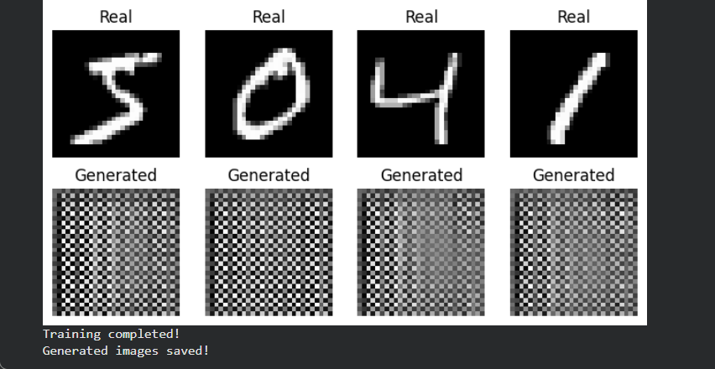
EXPECTED OUTCOME
Students will understand the architecture and working of Generative Adversarial Networks (GANs) and the interaction between the Generator and Discriminator during adversarial training. Students will learn to preprocess image data, build and train GAN models, and generate synthetic images. They will evaluate the generated images by visually comparing them with real images and analyzing the improvement in image quality during training.

POST-LAB QUESTIONS (PROVIDE BRIEF ANSWERS TO THE FOLLOWING QUESTIONS)

- What is the role of the Generator in a GAN?
The Generator creates synthetic or fake data, such as images, from random noise. Its goal is to generate data that looks as realistic as possible so that the Discriminator cannot distinguish it from real data.

- What is the role of the Discriminator in a GAN?
The Discriminator classifies the input data as real or fake. It receives both real images and images generated by the Generator and learns to identify whether they are genuine or synthetic.

- Why is random noise used as input to the Generator?
Random noise provides the Generator with a starting point for creating different samples. By using different random noise values, the Generator can produce a variety of new images instead of generating the same image every time.

- What happens when the Discriminator becomes too strong during GAN training?
If the Discriminator becomes too strong, it can easily identify all generated images as fake. This provides very little useful feedback to the Generator, making it difficult for the Generator to improve and causing training to become unstable.

- What is meant by mode collapse in GANs?
Mode collapse occurs when the Generator produces only a limited variety of outputs, often repeatedly generating very similar or identical images. As a result, the GAN fails to represent the full diversity of the training data.

- How does the Generator improve the quality of generated images during training?
The Generator receives feedback from the Discriminator about how realistic its images are. It uses this feedback through backpropagation and optimization to update its weights and gradually produce more realistic and higher-quality images.

- Mention one real-world application of GANs.
One real-world application of GANs is image generation, such as creating realistic human faces that do not belong to real people.

- What is the difference between GAN training and conventional neural network training?
In conventional neural networks, a model usually learns from known input-output pairs or a defined objective. In GANs, two networks—the Generator and Discriminator—are trained together in competition, where the Generator tries to create realistic data and the Discriminator tries to detect fake data.

SUGGESTIONS FOR DATASETS
- MNIST Handwritten Digits – https://www.tensorflow.org/datasets/catalog/mnist
- Fashion-MNIST – https://www.tensorflow.org/datasets/catalog/fashion_mnist
- CIFAR-10 – https://www.tensorflow.org/datasets/catalog/cifar10
- CelebA – https://www.tensorflow.org/datasets/catalog/celeb_a
- Oxford-IIIT Pet Dataset – https://www.tensorflow.org/datasets/catalog/oxford_iiit_pet

ASSESSMENT
Description | Max Marks | Marks Awarded
Pre Lab Exercise | 5
In Lab Exercise | 10
Post Lab Exercise | 5
Viva | 10
Total | 30
Faculty Signature

